*Lab 2: Capacitors and Time Dependent Signals*

Physics 411

John Waczak

10/30/2016

Lab Partner: Kyle Tafoya

**Introduction / Background**

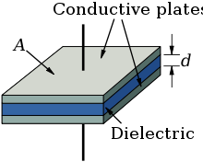

Figure 1: An example of a parallel plate capacitor

Lab II examined the properties of the passive component called the capacitor. In its simplest form, a capacitor is essentially two conductive plates separated by a dielectric like some type of polymer or air. As a voltage is applied to the capacitor, the plates store equal and opposite electric charge. Figure 1 to the right shows an example parallel plate configuration. The charge stored on the plates can then be discharged to power another component for example or used in conjunction with a resistor to filter a particular band of AC frequencies.

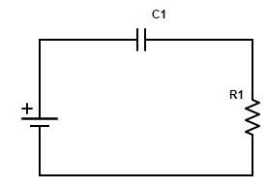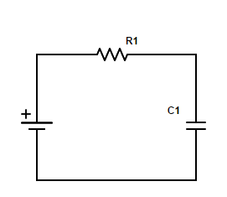 When a capacitor is put together with a resistor it forms what is called an RC circuit. Figure 2 and 3 show the two possible configurations. When an alternating current is passed through the RC circuit, the charging/discharging nature of the capacitor leads to some interesting behaviors. In both cases, one can consider the complex impedance (i.e. the ratio of voltage over current) of the components act in a similar fashion to the voltage divider studied in lab 1.

Figure 2: RC Circuit

The charge across the capacitor is given by the equation:

Where C is the capacitance, measured in units Farads.1 Thus the equation for the current (as a function of frequency) where the charge across the plates is periodic (i.e. the input is AC) is:

Figure 3: CR circuit

This leads to the reactance:

As mentioned above, both the RC and CR circuit can be analyzed as voltage dividers for the complex reactances of the components. This results in the voltage divider equations:

where is the cutoff frequency. Lab 2 consisted of 5 experiments (labelled 2 through 6 as the first was just to set up the oscilloscope) that analyzed the time and frequency dependencies of capacitors and the two circuits shown above. The following report will detail the results of those experiments in order to create a comprehensive picture for the uses of capacitors.

**Circuit Design / Experimental Procedure**

*2. Time-Dependent analysis of RC circuits*

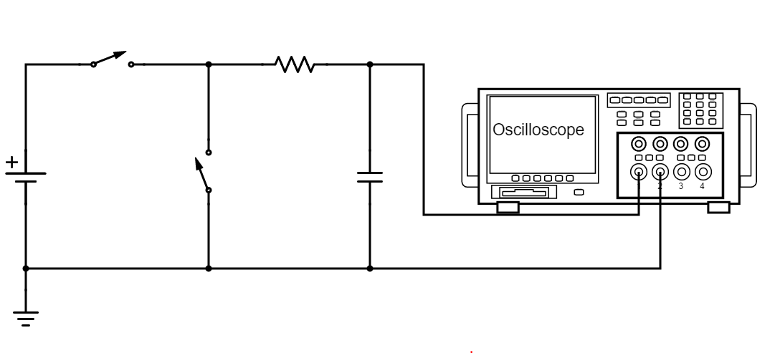 Figure 4 below shows the experimental set up for the circuit used to test the charging and discharging capabilities of the RC circuit.

Figure 4: circuit setup - experiment 2.a.

The values for R and C were 200kΩ and 0.473μF giving a time constant value of 0.0946. Experiment two part (a) tasked us with capturing the charging and discharging behavior for the RC circuit using the oscilloscope. Signals were measured on the oscilloscope and then captured onto a flash drive in a .csv file using the “print” button.

The expected behavior of the time dependence of Voltage for the RC circuit is:

Our goal was to empirically measure the time dependence in order to compare it to RC and to see if there was any difference in value between the charging and discharging actions. To charge the capacitor, the second switch was left open while the first switch was closed. In order to then discharge the capacitor, the switch to the power supply was opened. Immediately after, the second switch had to be closed due to the inherent capacitance of the oscilloscope probe.

Part b of experiment 2 replaced the power supply and switches instead with a function generator. Vin was set to a 5-volt square wave and again the time dependence of Vout was captured with the oscilloscope. Figure 5 below shows the adjusted circuit diagram for part b:

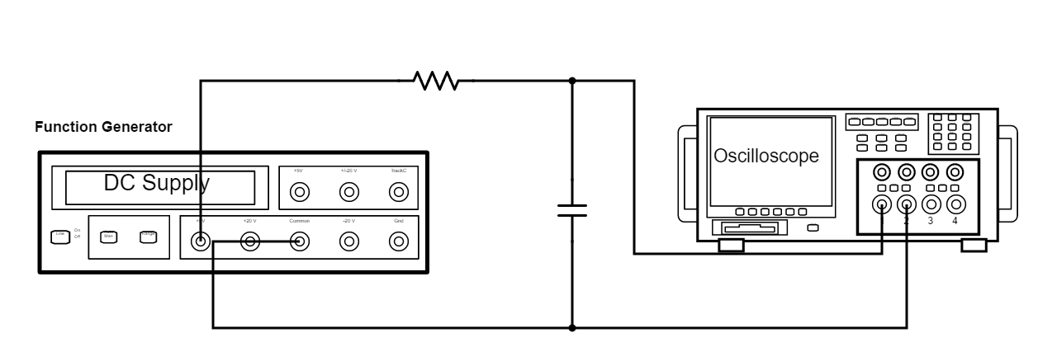

Figure 5: circuit - Experiment 2.b.

The value for R and C were adjusted for part b to 21.8kΩ and 0.473μF giving a time constant RC of 0.0103. The same measurements were made and then, the input frequency was varied from 0 to 100 kHz to determine the range of frequencies over which the circuit continued to show the same behavior as at the regular 100 Hz frequency.

*3. The RC integrator*

For experiment 3, the same circuit was used and the output signal was analyzed for a 100Hz input square wave to see if the RC circuit is consistent with the label of an “integrator”. We then varied the frequency in order to see over what range it behaves as an integrator. Finally, an input signal of a 100Hz triangle

*4. The CR configuration*

For experiment 4, the same procedure as experiment 3 was followed except the configuration of the resistor and capacitor was switched to that of the CR circuit pictured below in figure 6.

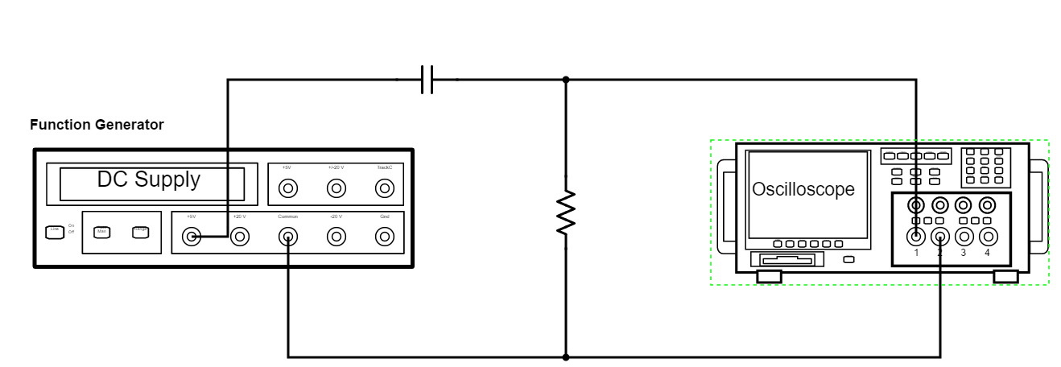

Figure 6: circuit - Experiment 3

*5. Response of both variations to complex waveforms*

In experiment 5, the modulation function on the function generator was applied to an input sinewave of 10kHz with 9kHz of modulation and 100% depth. We were tasked with capturing the input and output signal as well as performing a Fast Fourier Transform through the oscilloscope to observe the peak frequency components of the signal. Waveforms were saved to a flash drive using the same “print” button on the scope as in previous examples.

*6. Frequency response of both configurations*

The final experiment in this lab, experiment 6, involved measuring the cut-off frequencies for the CR and RC configurations by measuring the input and output voltages over a range of frequencies in order to construct a Bode plot. The bode plot uses a logarithmic scale; 20log(A(f)) vs Log(f) where A(f) the transmission function is equal to the magnitude of the ration of Vout to Vin. The cut-off frequency occurs at the -3dB mark. Our goal was to determine this frequency empirically and then compare it to the theoretical value .

**Results/Data**

2. Time-dependent analysis of RC circuits

Graph 1 shows the captured signal for the charging cycle of the capacitor after closing the switch to the power source. The data shows the clear exponential growth. The time constant as determined from the 1-1/e point on the graph is 0.0896. This differs from the theoretical value of 0.0946 by 0.005 seconds.

Graph 1: RC circuit - charging

Graph 2 to the right shows the captured signal for the discharging cycle of the capacitor after opening the first switch and closing the second immediately after. This data also shows clear exponential behavior. The 1/e time on the graph is measured to be 0.0996 which differs from the theoretical value of 0.0946 by 0.005 seconds as well. As excel cannot plot a trend-line for behavior that switches between exponential and constant, these values were calculated by finding the difference in time between the last point before any change in slope and the point at the (1/e) or (1 – 1/e) value. This data is very reassuring as we should expect the values for the two time constants to be the same regardless of whether or not the capacitors are charging or discharging.

Graph 2 RC circuit - discharging

Graph 3 (next page) shows a sample of the voltage across the capacitor when the switches were taken out and replaced with a square wave from the function generator (part b of experiment 2). As you can see, there is once again clear exponential behavior on both the charging and discharging cycles.

Graph 3: RC circuit with Square wave input

The measured values for the time constant were 0.0099 and 0.0094. The theoretical value for RC was 0.0103 so the difference in each case was 0.0004 and 0.0009 respectively. Again, the values have shown to be very nearly the same value reaffirming again that Tau should be the same for both the charging and discharging cycles.

*3. The RC integrator*

For experiment three, as mentioned above, the same circuit was used from part 2.b. Graphs 4, 5, and 6 below show the time response for three different input frequencies into the RC circuit showcasing how as the frequency is increased, the “integrator” behavior begins to take shape.

Graph 4: RC circuit 100 Hz

Graph 5: RC circuit - 10 kHz

Graph 6: RC circuit - 1 MHz

As you can see above, the “integrator” response of the RC circuit refers to the fact that upon inputting a square wave signal, the output is a triangle wave for certain frequencies (i.e. the integral of a constant is a line of constant slope). After slowly sweeping the input frequency from 10Hz to 1MHz, we found that the “Integrator” did not persist past 15kHz.

Graph seven shows the output signal when the input was changed to a triangle wave.

Graph 7: RC circuit output, Triangle wave input

Clearly, the RC circuit is acting as an integrator (The frequency is at 100 Hz) however the question is what function is the integral the periodically changing linear function. The answer, as is evident above, is that the integral of a function f(x) = x raises the power of the argument by one degree. Thus, you can see that over one quarter of the period, the output appears to look like a parabola. This may explain why there is strange behavior at each crest as the slope quickly changes sign.

*4. The CR configuration*

Experiment 4 asked us to perform the same procedure as for experiment 3 in order to test the behavior of the CR configuration in the same manner. The main question was whether or not the CR circuit behaves as an integrator, differentiator, or neither. Below, graphs 8, 9, 10, and 11 show the output voltage as a function of time for four different frequencies.

Graph 8: CR circuit - 100 kHz

Graph 9: CR circuit - 50 kHz

Graph 10:CR circuit - 1 kHz

Graph 11:CR circuit - 500 Hz

As you can see from the graphs above, the CR circuit acts as a High Pass filter (as opposed to the RC circuit) allowing in almost all of the signal at high frequencies and becoming a “differentiator” at frequencies below 500 Hz. The derivative of a constant is zero however due to the infinite slope at each quarter period, there is a spike attributable to a delta function resulting from this harsh jump.

The behavior of the CR circuit when given a triangle wave is shown below in graph 12:

Graph 12: CR circuit output - triangle wave input

As you can see, the circuit again performs as a “differentiator” taking the input linear regions (first order polynomials) and differentiating them to constants returning back a square wave.

*5. Responses of both configurations to complex waveforms*

In experiment 5, the response of the RC and CR configurations to a 10kHz sine wave with +/- 9 kHz of modulation was explored. Graph 13 below shows a snapshot of both the input and output signals for the modulated input.

Graph 13 Modulated input signal and response

Using the Fast Fourier math function on the Oscilloscope, dB plots in frequency space were made for the CR and RC configurations. Graphs 14 and 15 show the frequency dependence of the transmission function:

Graph 144: CR circuit - Fast Fourier Transform:

Graph 15: RC circuit - Fast Fourier Transform

Each graph clearly shows three distinct “bands”: The middle band at 10kHz and the two side bands at 1 and 19 kHz respectively. In the CR FFT it is clear to see the -6 dB drop described in the experiment guide however this behavior was not present for the RC FFT (shown in graph 15) despite using the same V/Div and Sec/Div settings for each configurations. This difference may be due to the different behavior of the two configurations.

*6. Frequency response of both configurations*

For the final experiment, the RC and CR configurations were tested once more in order to determine their characteristic frequency (aka cut-off frequency). This was accomplished by varying the frequency of the input square wave and measuring both the input voltage and the output voltage along with the phase difference between the two. Then, these were used to construct a “Bode” plot—a logarithmic plot comparing the magnitude of Vout/Vin versus the frequency. The bode plots for the RC and CR configurations are shown below in graphs 16 and 17.

Graph 16: RC bode plot

Graph 17: CR bode plot

The above graphs clearly show the difference between the two configurations: The RC circuit is a low pass filter and the CR a high pass filter. Graph 16 shows both the experimental values and the graph for the best fit (using the Chi Squared method shown in class). The CR plot shows the experimental values and the theoretical values as I could not make the chi squared value converge using the solver feature on excel. The theoretical value for the cut off frequency for both cases was 3.315kHz. This showed to be right on for the CR plot as you can see by the clear overlap between the theoretical and experimental data however, the calculated cut off frequency for the RC circuit was less at 2.957 kHz – not a substantial difference, but different all together. This is likely due to some minor confusion with the TTL sync having some problems as we moved towards higher frequencies. Also, this was the first time I performed a chi squared fit by hand and may have made some minor calculation errors in using excel.

**Conclusions/Discussion**

This lab demonstrated the plethora of uses for the capacitor. Experiment 2 showed how the capacitor charges and discharges and specifically how that rate is dependent upon the value of the capacitor’s capacitance. Experiment 3 illustrated the properties of the RC circuit – namely its behavior as a low pass filter and “integrator”. Experiment 4 explored the properties of the converse configuration, the CR circuit and its behavior as a high pass filter and “differentiator”. Experiment 5 tested the response of both configurations to a modulated signal. Finally, experiment 6 demonstrated how to find the cut-off frequency for the complex circuits and how the Bode plot shows the linear drop off after the cut off frequency.

When taken together these experiments form a comprehensive picture for the complex analysis of RC circuits and how to use them to filter out particular bands of AC signal noise. In almost every situation, the behavior of the components matched the theoretical models.

Sources:

1. <https://en.wikipedia.org/wiki/Capacitor>
2. Schematics.com